# Lab 7 Cloud Infrastructure Management Date: 5/3/2024

Carry out an experiment to create an API and explore

Create API management console

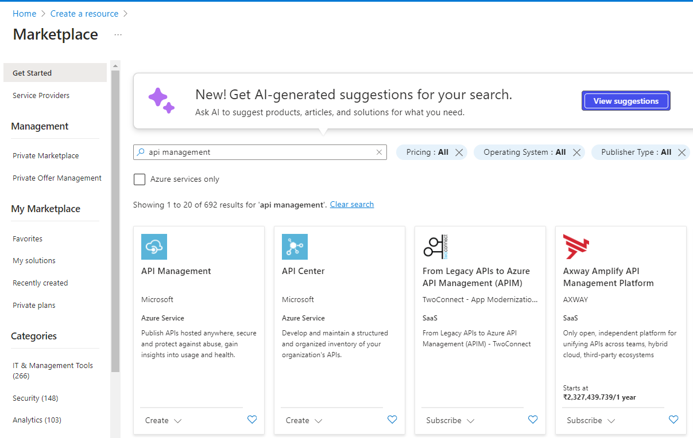

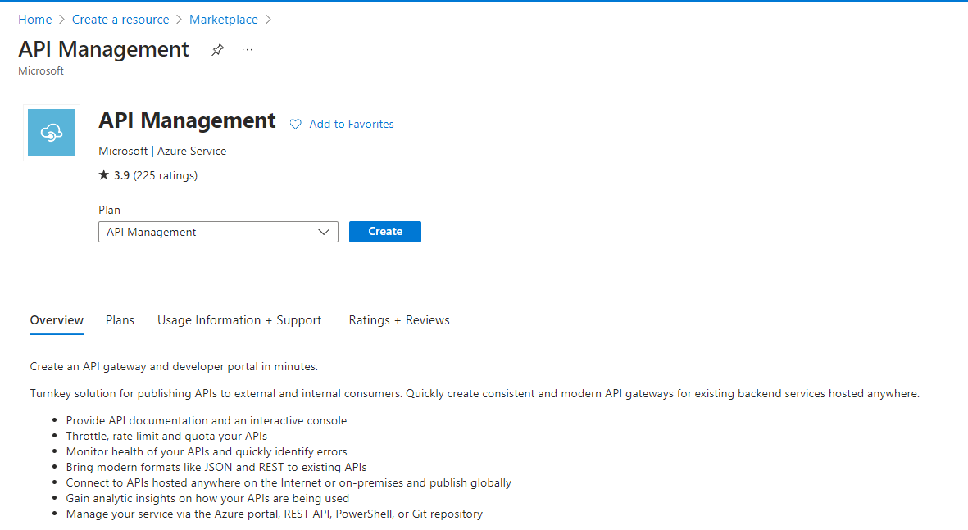

Give all important information regarding API management and Click Create

Goto API management dashboard, Goto API section to create new API

Create new HTTP API with the following details

Configure the API endpoint with relevant information.

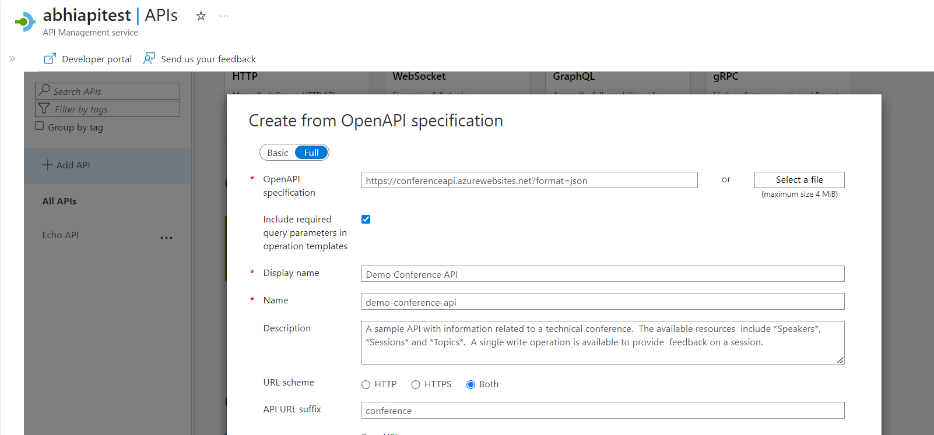

Check the new create API section and test its working.

­­­